

HAP 618 Computational Tools in Health Informatics

Prof Ying Wang

**ONLINE HEALTH TRACKER**

Author: **Chandrika Machavarapu**

Spring 2020

May 11, 2020

**Project Description**

The notion behind the project is to develop an online health tracker which helps the users to track the characteristics like calories they need to burn or gain in order to maintain the normal weight. The primary step is to create an account by providing email, username and password then the user inputs name, age, height(in Centimeters),sex and weight(in Kgs) then the persons BMI is calculated then it results in the weight which is more than the usual one and show the status of obese. It will also ask the person for the calories input they takes on daily basis then the BMR is calculated and it shows the actual BMR value and suggested BMR value in order to maintain normal weight. The data is recorded users can access the historical data in the form of both table and graph and see how the values are changed over time.

**Software’s used**

* Python
* MySQL Database
* Flask API Framework
* HTML
* CSS
* Java Script
* XAMPP

**Python Libraries**

* click==7.1.1
* Flask==1.1.2
* Flask-Cors==3.0.8
* itsdangerous==1.1.0
* Jinja2==2.11.1
* MarkupSafe==1.1.1
* mysql-connector==2.2.9
* six==1.14.0
* Werkzeug==1.0.1

**Design of the solution**

For the project I used Python, HTML, CSS, Java Script, and Flask Routes. All these codes intertwin within each other to bring the project together. All these codes have been executed on local server on my computer

There are few Python codes that are on my personal device. The project is not interactive, it consists of static webpages, except the bar charts refreshes with updated data. It was mainly designed to calculate BMI, BMR values and show graphs related to user daily workout information

Python was used to as the main backend code which calculates BMI and BMR values based on inputs taken from html. The core part lies in flask routes, on click of a button in UI/HTML pages. It redirects python function where actual business logic was written. This business logics return data to flask routes which will render respective HTML page according to data received.

* The python libraries that were used in the Python program are mainly Flask, Flask_cors, mysql_connector with specified versions and related dependent libraries.
* Flask and Flask Cors are used for flask routing purpose.
* MySQL connector is utilized to connect to database with python using connection string.
* HTML is used to build web pages for different purposes in this web application. The  
  following are the webpages used in this project

**Createaccount**

In this page user inputs necessary parameters which contains in the form to create account.

**Login**

In order to login user needs to input username and password.

**Profile**

Here, user inputs his/her weight, age, sex, height and other parameters to calculate BMI and BMR values

**Profilefreze**

In this page we Display already entered information of User

**Daily record**

In this page user inputs intake and consumer calories in order to recorded them in form format

**Dashboard**

Here we display the stored workout information of that particular user

**Graph**

Displays four graphs with different notion respecting to workout information

* CSS is used to style the above web pages.
* XAMPP is the software which provides database and local server called apache. XAMPP comes with inbuild database MySQL and server apache. Our application runs on local machine with this apache server and this database MySQL.
* In MySQL we have created a database with name `health_tracker`. This database consists of there tables where each table does specific task.
* The following are the database table names
  + Dashboard
  + Personalprofile
  + User

**Project Flow Diagram**

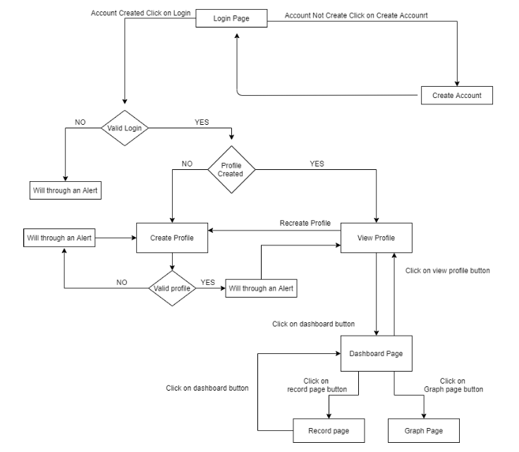

*Figure 1: Conceptual architecture*

**Implementation**

This project was implemented using **two methods** Xampp server which is a platform dependent and a File Zilla which helps to view the website platform independent which is detailed below.

**Method 1**

**Initial steps to be Followed**

* Open Xampp control panel and start running apache server and MySQL server
* Open Command prompt
* Redirect the command prompt to project location
* Run the python file __init__.py
* Copy the URL obtained to any Browser

**Steps to followed on opening application/webpage with above URL**

* User needs to create account on clicking the link given and Provide necessary details.
* User needs to Login into application using the credentials he/she already created.
* Fill the Profile Information form and Submit.
* Now User can see his BMI value, BMI category and BMR values calculated.
* Further user can record his daily information of calories burnt per day. Then system prompts in how many months he comes to normal weighted person, where BMI value will be good.
* On click of Dashboard button user can see his/her recorded data
* On click of Graph button it redirects to page where he/she can see their stored information in Graphical format.

**Login Page**

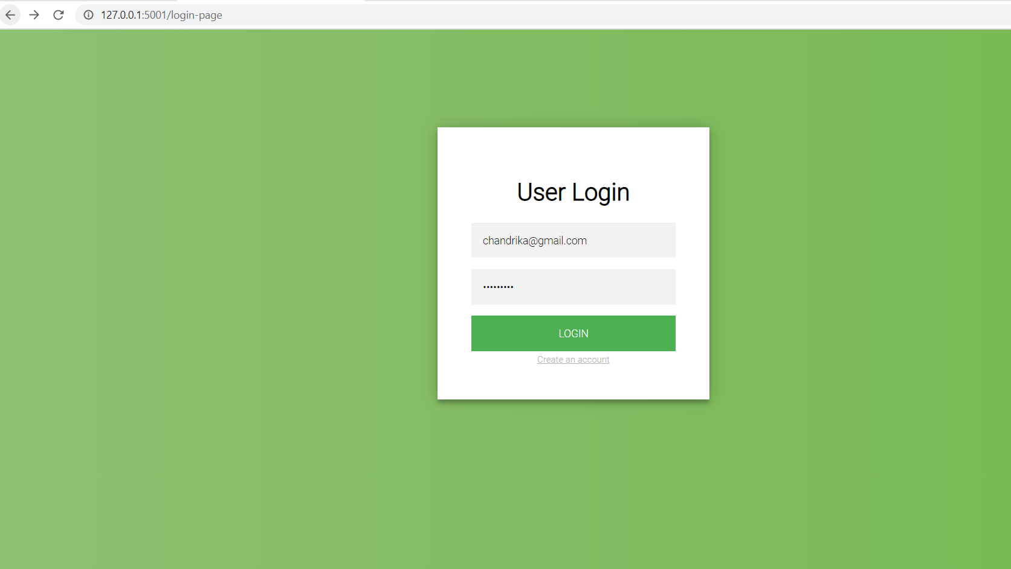

*Figure 2: Showing the login page where the user enters the login details and also an option to create an account.*

**Code(HTML)**

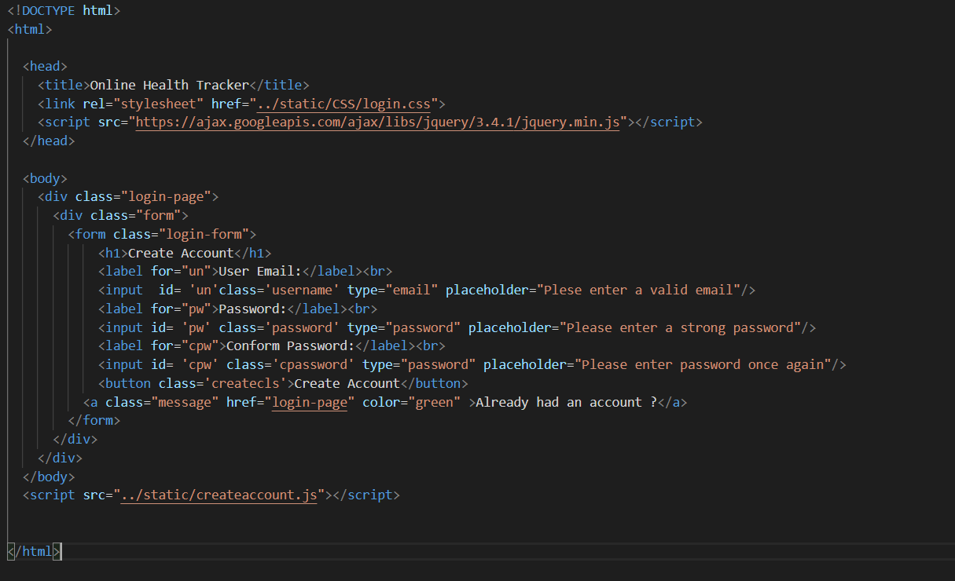

*Figure 3: Code for the login page*

**BMI Calculated Page**

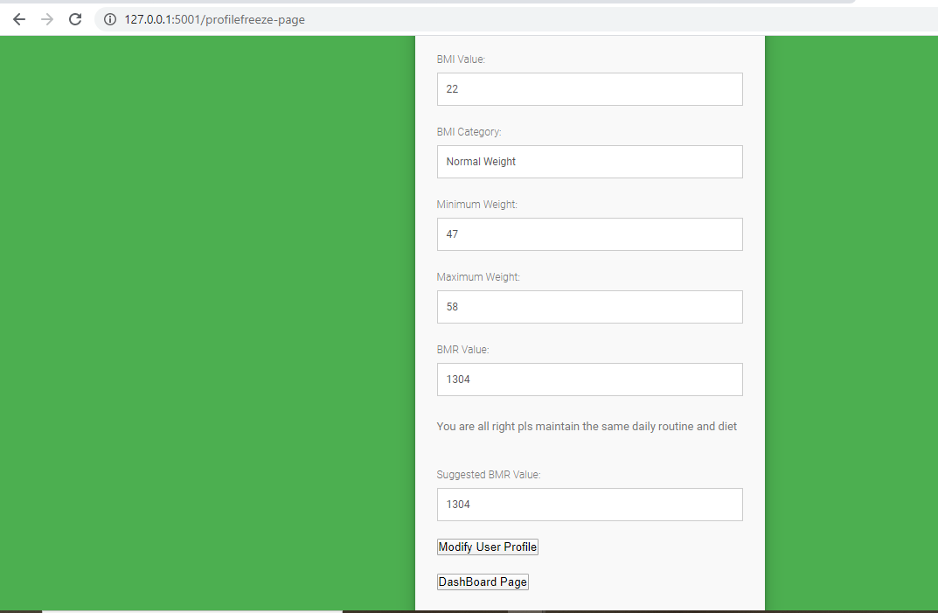

*Figure 4: BMI Calculated page and user needs to enter the details required in form*

**Python code to calculate BMI**

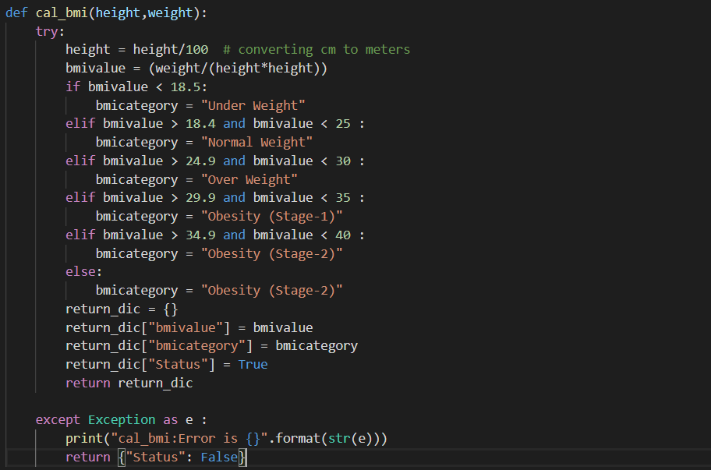

*Figure5: Function for calculating the BMI*

**Code Snipped to calculate BMR Value**

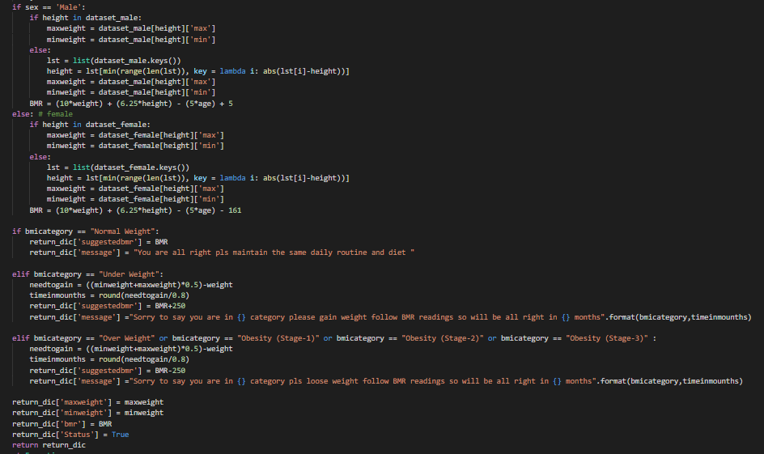

*Figure6: Depicting the fields to be displayed in the form and the formulae for calculating the values for each field accordingly.*

**Daily Workout information storage**

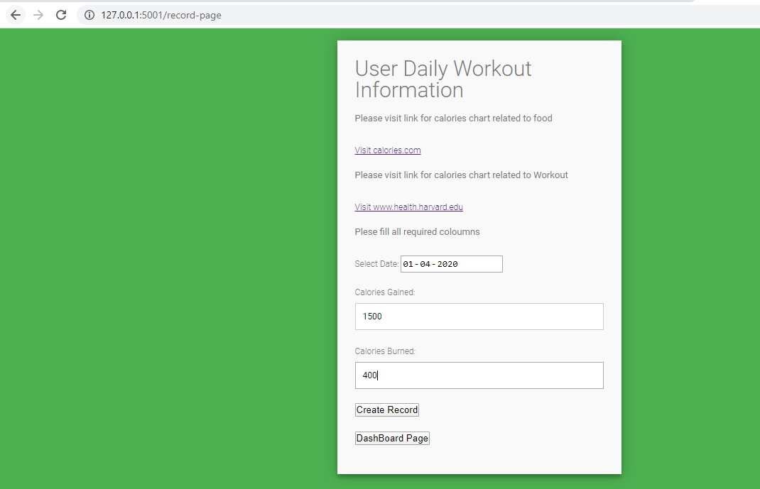

*Figure 7: Showing the user daily workout information page*

**Code Snippet to record daily workout information**

We can see here how we are inserting data to Database using query.

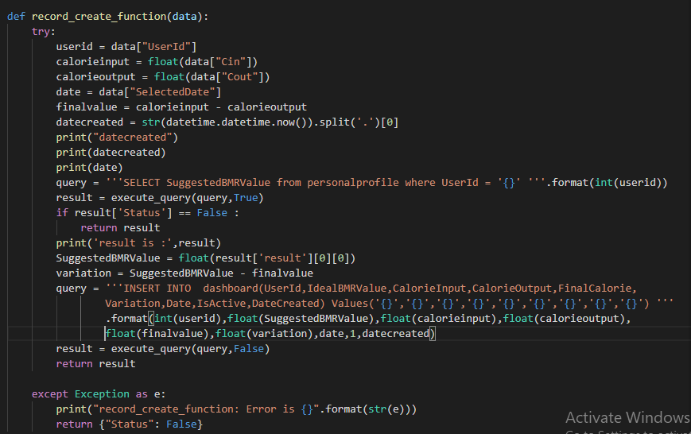

*Figure 8: Function to insert data to database(records)*

**Flask Routes**

Here in this code snippet we can see that I am importing Flask,render_template,request,jsonify from flask library,and these are responsible for functioning between python code and HTML code. On click of button in HTML after filling any form with data, it calls that particular route with along with data given in ths form.

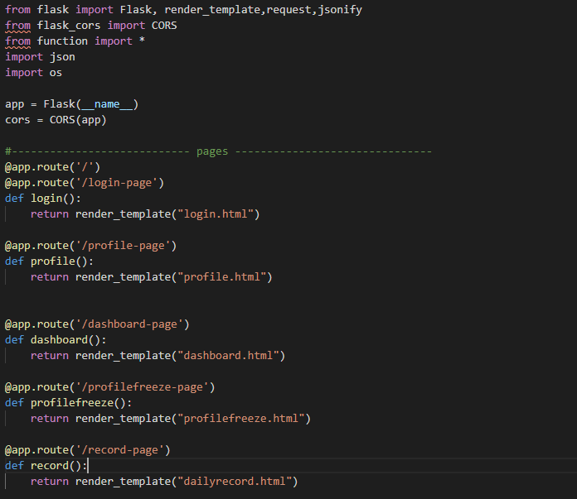

*Figure 9:Routed for navigating the pages*

**Code Snippet which connects to database using python**

The mydb variable is created using mysql.connector which a python library.

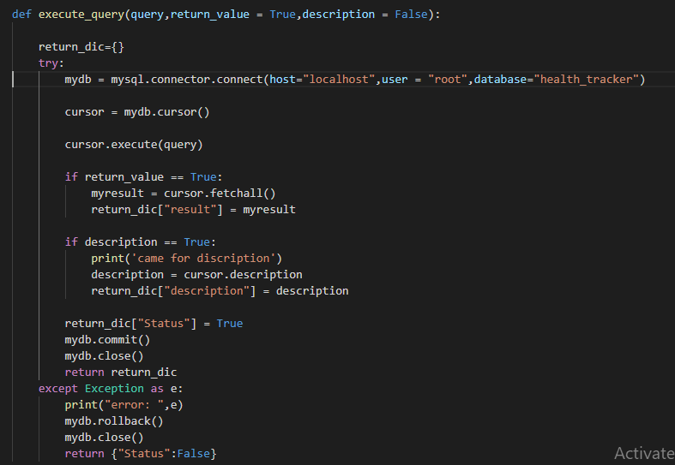

*Figure 10: Code for connecting to database*

As this is local server apace and local database MySQL the following are the parameters to connect to database.

* Host - ‘localhost’
* User - ‘root’
* database ‘health_tracker’

**XAMPP**

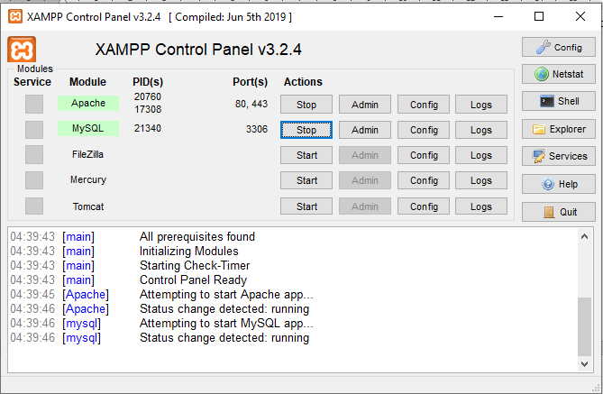

*Figure 11: showing which serves to on in the XAMPP control panel*

**DATABASE**

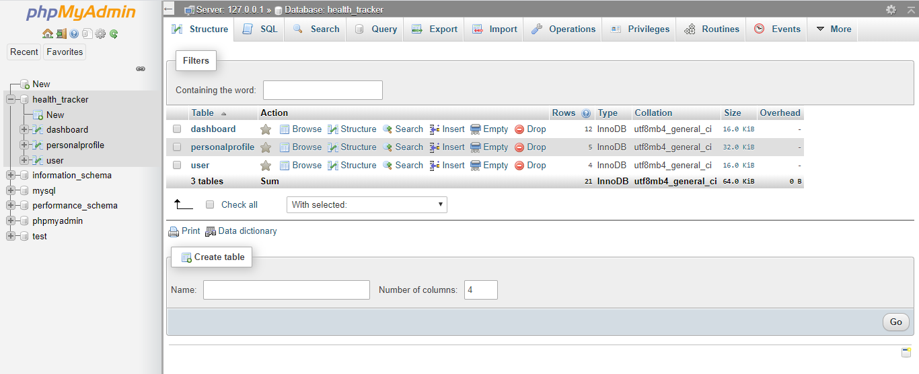

*Figure 12: components in a database*

The above image shows the database health_tracker which contains three tables

**Result Pages**

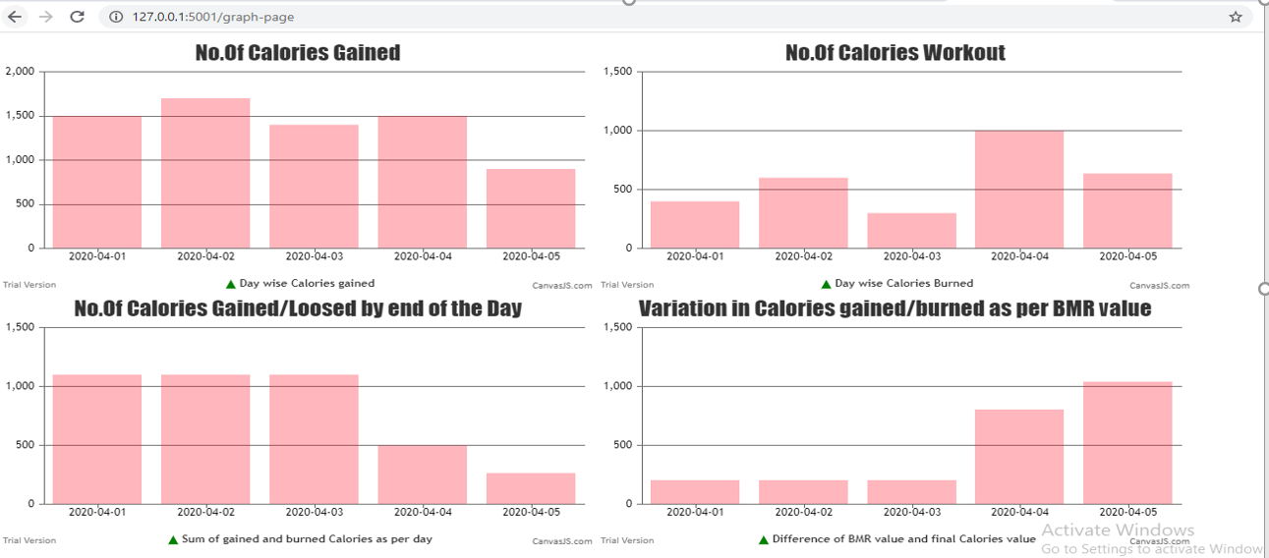

*Figure 13: Graph page which is showing the results*

**Code snippet to display graph**

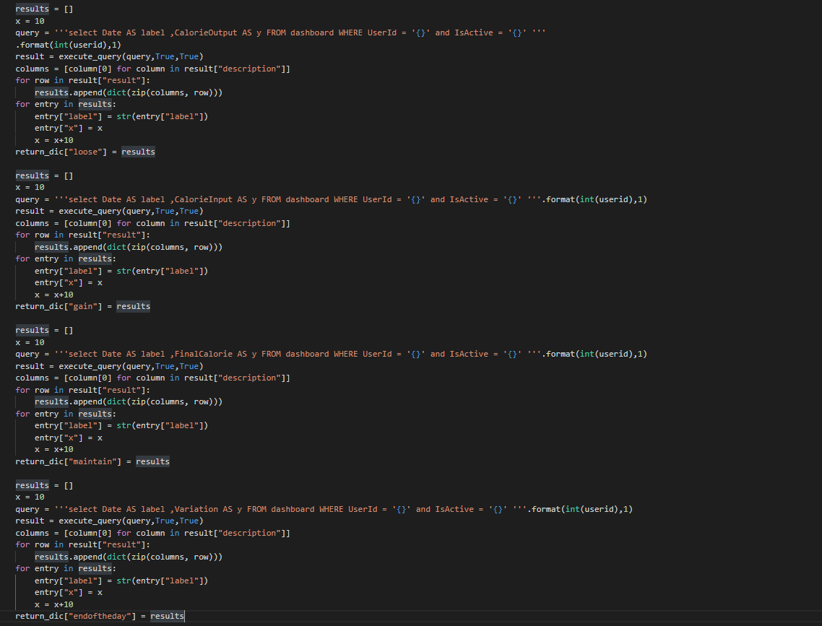

*Figure 14: Code used to visualize the graph*

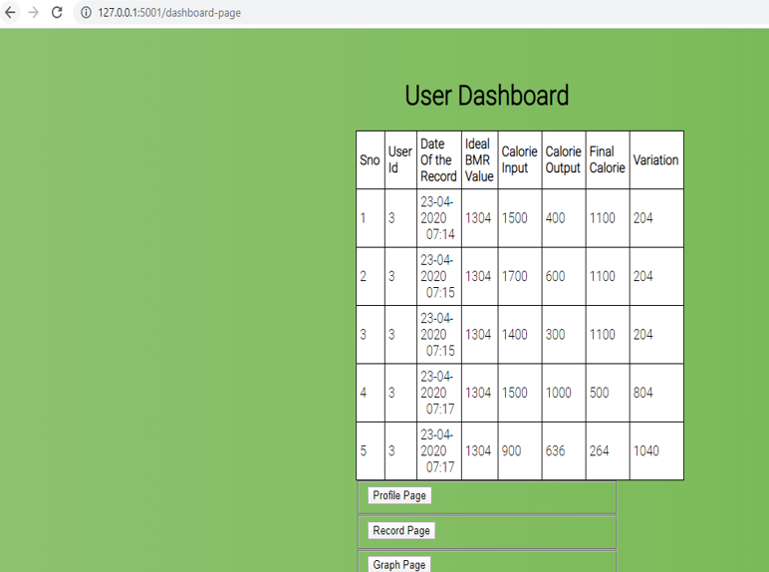

*Figure 15: Dashboard page showing results in the form of table*

**Method 2**

In the above method one which is described has the details and the procedure implemented for the publishing the website illustrating all the webs involved within it showcasing the navigational components for each click. But the backlog of using the Xampp server is the web page can be viewed locally but cannot be published universally so, in order to make it universal and platform independent the mason server was used to publish the websites globally through a link with the help of the file-zilla client server and putty (windows). Putty is used to manage the permissions like read and execute for the files in the public space in the server. The server was connected using the CISCO VPN any connect through which the mason.gmu.edu server was connected and used the free server space to publish my website.

Link:<https://mason.gmu.edu/~cmachava/Online_tracker/templates/createaccount-page.html>



*Figure 16:Connecting to the mason server using Cisco AnyConnect Client.*

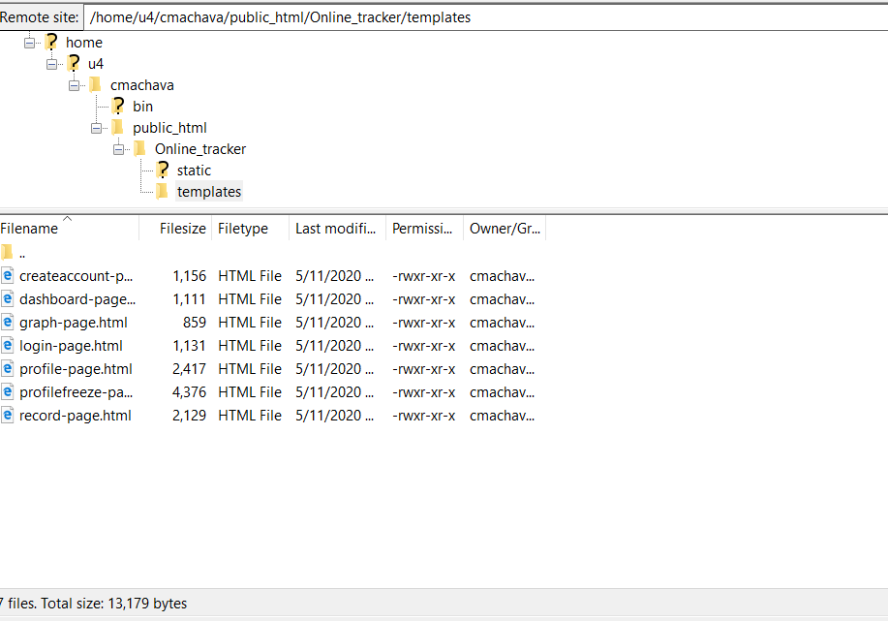

*Figure 17:Showing the remote server where the files are uploaded from the local site.*

**Conclusion**

Developed an Online Health Tracker web application using HTML, Python, CSS and SQL. By using this Online Health Tracker users can track the characteristics like calories they need to burn or gain in order to maintain the normal weight and they can see how their results are changed over time in the form of both table and graph.

Please access the below GITHUB link to access the source code and supported files.

<https://github.com/chandumachavarapu/Online-Health-Tracker>

**References**

* [https//canvasjs.com/docs/charts/how-to/render-multiple-charts-in-a-page/](https://canvasjs.com/docs/charts/how-to/render-multiple-charts-in-a-page/)
* [https//canvasjs.com/jquery-charts/column-chart/](https://canvasjs.com/jquery-charts/column-chart/)
* [https//www.calories.info/food/fruit-juices](https://www.calories.info/food/fruit-juices)
* [https//www.calculator.net/calorie-calculator.html](https://www.calculator.net/calorie-calculator.html)
* [https//www.health.harvard.edu/diet-and-weight-loss/calories-burned-in-30-minutes-of-leisure-and-routine-activities](https://www.health.harvard.edu/diet-and-weight-loss/calories-burned-in-30-minutes-of-leisure-and-routine-activities)
* [https//colorlib.com/wp/template/creative-login-form/](https://colorlib.com/wp/template/creative-login-form/)
* [https//colorlib.com/wp/template/colorlib-contact-form/](https://colorlib.com/wp/template/colorlib-contact-form/)
* [https//www.w3schools.com/](https://www.w3schools.com/)
* Class Notes.